Unit Topic:
The Rainforest
Grade 5 (ALP classroom)

Summary of Unit: This unit helps students understand one kind of system (the rainforest), and how its components work together and separately. Students will start to see that our lives and other living things revolve around systems working.

Unit Objectives:
Students will start to build their foundational knowledge to help them reach these two goals.
1. Goal 1.1: Understand Systems, Order, and Organization
2. Goal 1.5: Understand Concepts of Form and Function

Standards
CCSS.ELA-Literacy.RI.5.3 Explain the relationships or interactions between two or more individuals, events, ideas, or concepts in a historical, scientific, or technical text based on specific information in the text. (compare and contrast.)

5.S.1.5.1 Explain how the shape or form of an object or system is frequently related to its use or function.

5.S.1.2.3 Use models to explain or demonstrate a concept.

5.S.1.3.1 Analyze changes that occur in and among systems.

CCSS.ELA-Literacy.W.5.8 Recall relevant information from experiences or gather relevant information from print and digital sources; summarize or paraphrase information in notes and finished work.

CCSS.ELA-Literacy.SL.5.4 Report on a topic or text or present an opinion, sequencing ideas logically and using appropriate facts and relevant, descriptive details to support main ideas or themes; speak clearly at an understandable pace.

5.S.1.2.1 Use observations and data as evidence on which to base scientific explanations and predictions.

110 | REPR O D U C I B L E

Backward Planning Unit Design Template

1. What power standard(s) will we address within this unit?

a. Student-friendly version of the power standard(s) to reference during instruction (“I will be able to . . .”):

I will be able to explain relationships or interactions between two or more ideas, events, concepts, and the texts we read in class. (CCSS.ELA-Literacy.RI.5.3)

I will be able to explain how the form and the rainforest’s system (eg., it’s layers, and living matter) makes the rainforest function. (5.S.1.5.1)

I will be able to understand and explain how changes that might occur could affect the rainforest’s system. (5.S.1.3.1)

I will be able to summarize and remember important information from in class sources to summarize information in notes and finished work. (CCSS.ELA-Literacy.W.5.8)

I will be able to use models to explain and show how parts of the rainforest work together to create a system. (5.S.1.2.3)

I will be able to explain my rainforest model and how it works as a system to the class and present it logically, sequence ideas correctly, use appropriate facts and descriptive details, while speaking clearly and not too fast. (CCSS.ELA-Literacy.SL.5.4)

I will be able to use the information and observations I have made as evidence to base my educated explanations and predictions. (5.S.1.2.1)

b. Big ideas to establish within the unit:

Students will be able to start to understand that systems, order, and organization always surrounds them in life. (Goal 1.1)

c. Essential questions that guides the learning:

What does it mean to view our lives and the world as being connected to many systems?
Why is viewing the rainforest as a system important?

2. What are the unwrapped knowledge and skills and aligned formative and summative assessments for this unit?

a. Students Will Know . . .  (What concepts and vocabulary support the standard?) | Formative Measures  (How will we monitor student progress on these concepts and skills along the way?) | Summative Measure(s)  (What culminating measure will we use to determine students’ overall attainment of this concept?)
Students will know the names of the four layers of the rainforest. | Exit ticket/Understory & forest floor 2 part activity/oral quiz/Venn Diagrams/four corners | Student’s own model of the rainforest.
Students will know why each layer is part of the rainforest’s system. | Venn Diagrams/ Understory & forest floor 2 part activity/Exit ticket/four corners | Student’s own model of the rainforest.
Students will know that animals, and all living things in the rainforest are codependent within the rainforest’s system. | Exit ticket/oral quiz/Venn Diagrams/four corners | Student’s own model of the rainforest.
Vocabulary: forest floor, understory, emergent, canopy, and system.
b. And Be Able to . . .  (What things should students be able to do as part of the standard?) | Formative Measures  (How will we monitor student progress on these skills along the way? Are there strong and weak models we can provide to students?) | Summative Measure(s)  (What culminating measure will we use to determine students’ overall achievement of this skill?)
Students will be able to compare and contrast different layers of the rainforest. | Venn Diagrams/Part 2 of the forest floor 2 part activity | Student’s own model of the rainforest.
Students will be able to build a model of ‘a rainforest’ to show and orally explain how all layers and living things are dependent on the rainforest functioning as an entire system. | All formative assessments | Student’s own model of the rainforest.
Students will be able to explain how each layer functions within the rainforest’s system (sometimes by making an educated guess with the knowledge that the rainforest is a system). | Exit ticket/forest floor and understory 2 part activity/oral examination/Venn Diagrams/ | Student’s own model of the rainforest.

Pre-Assessment
Purpose
The main of this assessment is to see what students already know about the rainforest, and to start making them think about our main idea, which is how the rainforest works as a system. For the teacher, this pre-assessment helps me know the general knowledge students have about the rainforest already.
Procedure
-Hand out a piece of paper to every student and tell the students this is a test, but they aren’t supposed to know everything on it. Make it fun and tell the students this will be a great way to see all that they have learned.

Rainforest Pre-Assessment
- Put the four layers of the rainforest in order going from the bottom to top.
Forest Floor, Emergent, Understory, Canopy
_____________________ ____________________ ____________________________ _____________________
- Does the rainforest work like a system? If your answer is yes, explain why.

- Why do you think it’s important to know what kind of plants and animals live in the rainforest?

4. List four facts you already know about the rainforest.

Purpose (cont.): This will get the students to start thinking about how the rainforest’s components work together, which helps me start teaching about how the rainforest is a system.
Procedure (cont.)

After the pre-assessment, there is material that is handed out that explains how important the rainforest is and why it is important to the ecosystem. This handout explains the climate and the type of animals that live in the rainforest. You can popcorn read or just read the information to the class. Reading out loud is a great way to help students with their fluency. I also always tell my students to annotate their text. They understand this means to underline and summarize important key concepts. All of this helps with their reading comprehension skills as they are learning about science.
After the students read the handout, the students will start on their activity where they draw each layer of the rainforest and put at least five animals and/or plants in each level. This is a great way to incorporate art. Then, the first formative assessment is handed out once all the handouts are put away.
This is an assessment for learning check for me and the students to make sure they are understanding what they are learning.

Formative Assessment #1
Exit Ticket (Forest Floor)
Standards:
I will be able to summarize and remember important information from in class sources to summarize information in notes and finished work. (CCSS.ELA-Literacy.W.5.8)
I will be able to use the information and observations I have made as evidence to base my educated explanations and predictions. (5.S.1.2.1)
I will be able to explain how the form and the rainforest’s system (eg., it’s layers, and living matter) makes the rainforest function. (5.S.1.5.1)

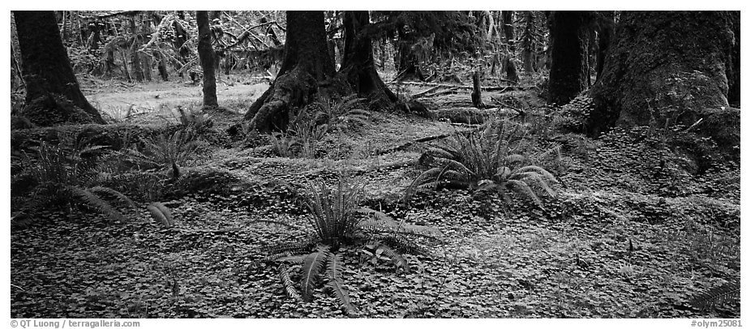
Exit Ticket  Forest Floor  9/18/13 | - Why do you think the rainforest needs the forest floor as the bottom layer? What do you think would happen if this layer did not exist?
- Name three animals/insects that live on the forest floor. Explain why each might be found living on the forest floor.
1.
 | 2.
 | 3.
 | 3.Why would less rain reach the forest floor compared to the other three layers of the rain forest?

Converting to Gradebook Data:
Question 1: 2 points
Question 2: 3 points
Question 3: 2 points
Exemplary  Gives two or more details when explaining ‘why’ and understands the material in depth.  7/7 | On Grade Level  Understands most of the material, gives at least one supporting detail when explaining ‘why’. Can name three insects and animals that live on the Forest Floor.  5-6 points | Needs Improvement (redo!)  Can’t explain why and/or name three insects/animals.  4 points or below

Formative assessment #2
Two Part Activity (Understory)

I will be able to summarize and remember important information from in class sources to summarize information in notes and finished work. (CCSS.ELA-Literacy.W.5.8)
I will be able to explain relationships or interactions between two or more ideas, events, concepts, and the texts we read in class. (CCSS.ELA-Literacy.RI.5.3)
I will be able to explain how the form and the rainforest’s system (eg., it’s layers, and living matter) makes the rainforest function. (5.S.1.5.1)
Procedure
Before reading or starting the lesson about the understory, have the students draw three things that belong to the forest floor or explain the forest floor. Give the students five to ten minutes to do this. Make sure they label what they are drawing.
Have the students read about the understory and complete the activity to draw the understory portion of the rainforest.
After, have the students complete this formative assessment by summarizing the understory layer of the rainforest, and one sentence explaining how the rainforest floor and understory of the rainforest are connected. This should help them start to understand how the understory and forest floor work together within the rainforest’s system. I incorporate writing here, with art, along with reading.

Draw and label three things that are characteristics of the Forest Floor
(After learning about the understory students will complete the bottom part of the paper.)
In one sentence summarize the understory layer of the rainforest.
In one sentence summarize/explain how the Forest Floor and the understory of the rainforest are connected.

Converting to Gradebook Data:
6 points for drawing and labeling characteristics of the Forest Floor
2 points for summarizing the Understory of the rainforest in one sentence with two details or more.
2 points for giving at least two details summarizing/explaining the Forest Floor and Understory are connected.

Exemplary  Draws all pictures and labels all pictures. Summarizes and explains in only on sentence as asked. Gives two or more details in both sentences.  10/10 | On Grade Level  Understands most of the material, gives at least one supporting detail when explaining and summarizing. Labels and draws most pictures.  7-9 points | Needs Improvement (redo!)  Does not draw all pictures and labels. Uses more than one sentence to summarize with no or inaccurate supporting details.  6 points or below

Formative Assessment #3
Oral Quiz for Learning (Canopy)
I will be able to explain relationships or interactions between two or more ideas, events, concepts, and the texts we read in class. (CCSS.ELA-Literacy.RI.5.3)
I will be able to explain how the form and the rainforest’s system (eg., it’s layers, and living matter) makes the rainforest function. (5.S.1.5.1)

May include: I will be able to understand and explain how changes that might occur could affect the rainforest’s system. (5.S.1.3.1)
I will be able to use the information and observations I have made as evidence to base my educated explanations and predictions. (5.S.1.2.1)

Procedure
Time to learn about the canopy layer. First, students read an informational piece of text about the canopy layer. Tell students to pay particular attention to the similarities and differences between the canopy layer and the other layers we have talked about since. This keeps them focused on how the rainforest works as a system, even though there are different layers. Think about the differences in plants, animals, and weather in the rainforest and why they might be different than where we live. The students then take about ten minutes to find the information they need to start drawing the canopy layer.
After the ten minutes, and after students find out what they want to draw, students are to put all of the informational text away and start on their drawing activity for the canopy layer of the rainforest. (This hopefully will prevent cheating.) As students are busy drawing, you can call up each student (one at a time) to give them an oral quiz on the canopy layer. Explain to students beforehand that this will help them prepare for the test, and this is only to let me and them know how they are doing, what they might need to be working on, and what may not be clear. Explain that this is positive, and is not a test.
Explain to the students they will be handed an image and write on the white board what three questions they will have to answer orally to you alone when they are called up one-by-one. Tell the students they can answer these questions by thinking back to the ‘data’ we have collected about the canopy layer and the other layers of the rainforest and how they work together or are different.
The questions
- What is the picture of? (Tell students to be broad, and give examples beforehand to the entire class by using this swan picture and answering that it is a bird.)
- How might this be different if found in the rainforest? (If it’s a bird, talk about a bird we learned about in class that lives in the rainforest. If it’s a picture of water, students should talk about how the rainforest might get more rain than Idaho.)
- How does this fit into the canopy layer of the rainforest?
- If this was no longer found in the rainforest, how might it affect the entire rainforest?
Example:
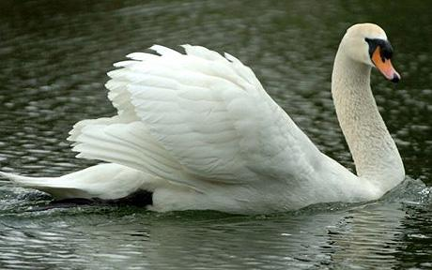
Some acceptable/example answers:
- This is a picture of a swan, which is a bird.
- A swan is not found in the rainforest, but toucans are. Any other details or another rainforest bird is acceptable.
- A toucan fits into the canopy because it lives in this area of the rainforest mostly. Toucans live in ‘shelter holes’ in the canopy layer which are holes in the tree trunks.
- Toucans eat a lot of insects, if there were less toucans, some layers of the rainforest, or all of them, might have too many insects which could affect the entire rainforest. The insects could take over the rainforest!
Before starting the oral quiz, print out images of plants, animals, or aspects in the weather. Have at least five different ones so the students don’t all get the same image. Images can be a picture of rain, tree roots, leaves, flowers, and animals. Show each student one picture (pick randomly).

Sit in the back of the room, and call up every student one by one. Show them the picture and ask ,” What is this a picture of?” Proceed to the next question-allow for a minute or two of ‘think time’ if needed, but no more. This is a great way to incorporate actual talking. Students need to learn how to articulate their thoughts.
In order to be at grade level, students need to be able to answer every question and give at least one detail for each question. If they can’t, give some ‘think time’. If the student still can’t after a minute or two, go on to the next question. If student still can’t, ask the student to bring up their rainforest text. Go through the text and show the students some answers and why they are the answers. The student then is given a different picture and asked the same questions once you have gone through every other student. If the student still is not able to answer the question, repeat this the next day until the student has mastered this oral quiz.

It is important to have a checklist as a rubric when conducting this oral quiz and to give the checklist back to the student to show the student his or progress and what he or he can continue to work on.
To get to every student takes time. Hand out the emergent layer text and have the students start reading this for the next science lesson. Tell them to annotate their text so they can remember what it says and think about how this layer compares to the other three layers of the rainforest we have already learned about.

Checklist Rubric
Question  Place checkmark next to an answer that is given correctly. Place multiple checkmarks in advanced box for every detail given past the first one. | Not Passed Student did not answer one question, or did not answer the question correctly. | On Grade Level  Student answers every question. Every question is answered with at least one detail. | Exemplary  Student gives more details than what is required.
1.What is the picture of?

2. How might this be different if found in the rainforest?

3.How does this fit into the canopy layer of the rainforest?

Formative Assessment # 4
Venn Diagrams to Compare and Contrast the Emergent Layer

I will be able to explain relationships or interactions between two or more ideas, events, concepts, and the texts we read in class. (CCSS.ELA-Literacy.RI.5.3)
I will be able to understand and explain how changes that might occur could affect the rainforest’s system. (5.S.1.3.1)
I will be able to summarize and remember important information from in class sources to summarize information in notes and finished work. (CCSS.ELA-Literacy.W.5.8)

I will be able to explain how the form and the rainforest’s system (eg., it’s layers, and living matter) makes the rainforest function. (5.S.1.5.1)
I will be able to use models to explain and show how parts of the rainforest work together to create a system. (5.S.1.2.3)

Procedure
Students already will have read the emergent layer text. To see if students understand what they read and how the emergent layer relates to the other three layers, have all students draw three Venn Diagrams. The right circle must be labeled “Emergent Layer” as everyone must compare this layer to another layer. Tell students they must have three Venn Diagrams with the emergent layer on the right, and one of the three layers on the left. In the end, they should be comparing all of the layers to the emergent layer. Students must have at least four facts for the Emergent Layer (itself), and two facts for the other layer. Students must find at least two similarities between the two layers they are comparing.

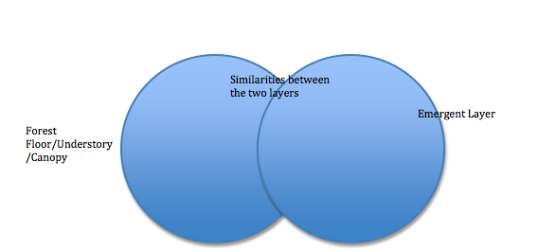

Give the students 25-30 minutes to recall all the information they know of each layer they are comparing. By understanding the aspects within each layer and how they might change or be connected to another layer, they might find a lot of similarities between the other three layers and the Emergent Layer. This is a great formative assessment to use to see if the students are starting to understand how each layer helps make up the rainforest’s entire system.

The rest of the time can be used to finish the rainforest art activity.

Converting to Gradebook: (use this rubric to grade every Venn Diagram separately.)
Emergent Layer has 4 facts
Similarities has 2 facts
Other layer has 2 facts
Exemplary  Student has 4 facts for the emergent layer and 2 facts for the other layer (or more). Student gives at least 2 similarities between both layers. All must be accurate.  10/10 | On Grade Level  Student gives at least 3 facts for one layer, and at least 1 fact for the other. Student finds at least 1 similarity for both layers. All must be accurate.  7-9 points | Needs Improvement (redo!)  Student has less than 2 facts for both layers and finds no similarities between both layers. There are many inaccurate facts.  6 points or below

To add a social studies component, have students read about how humans have affected the rainforest. Then, have students make a ‘world’ by cutting out two circles and folding each in half. Put the halves together with glue. There should be 4 sides of the circle. Have students write a reason why the rainforest is important on two sides of the circle and have them draw a picture. For the other two sides, have students write a way that humans have affected the rainforest and have them draw a picture explaining their thoughts.

Formative Assessment #5
Four Corners to Review

This assessment helps to achieve the parts of the goals this unit focused on:
-Goal 1.5: Understand Concepts of Form and Function
-Goal 1.1: Understand Systems, Order, and Organization

I will be able to use the information and observations I have made as evidence to base my educated explanations and predictions. (5.S.1.2.1)

Procedure:
This is a great review to show what the students know, and what they are still confused about. It is an easy formative assessment to quickly write down how many students went to each, and what layer. This shows what/where/how the students are confused, and what more they need to learn. First, you ask the question and ask the students to walk to what layer they feel answers the question. After writing down the number of students at each layer, you can use this time as ‘learning time’, and clear up some confusion.

Be sure to label four corners in your classroom with each layer of the rainforest!
Rainforest Floor | The Understory
The Canopy | The Emergent
Example with questions and keeping notes on the number of students at each layer after each question was asked:
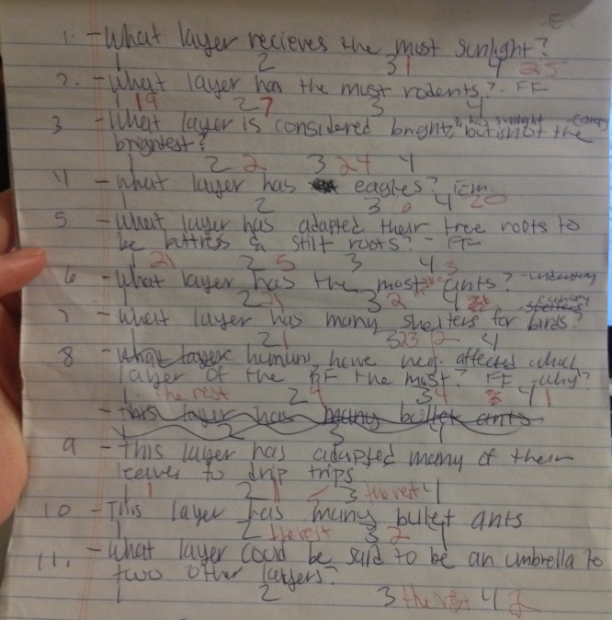

This is a great way for students to get up and moving. To play this game, it might be a good idea to go outside and have students actually run around to each corner.

Post Assessment
Rube Goldberg Rainforest System
Standards:
I will be able to explain relationships or interactions between two or more ideas, events, concepts, and the texts we read in class. (CCSS.ELA-Literacy.RI.5.3)
I will be able to explain how the form and the rainforest’s system (eg., it’s layers, and living matter) makes the rainforest function. (5.S.1.5.1)
I will be able to understand and explain how changes that might occur could affect the rainforest’s system. (5.S.1.3.1)
I will be able to summarize and remember important information from in class sources to summarize information in notes and finished work. (CCSS.ELA-Literacy.W.5.8)
I will be able to use models to explain and show how parts of the rainforest work together to create a system. (5.S.1.2.3)
I will be able to explain my rainforest model and how it works as a system to the class and present it logically, sequence ideas correctly, use appropriate facts and descriptive details, while speaking clearly and not too fast. (CCSS.ELA-Literacy.SL.5.4)

Purpose
By now, students should be understanding how the rainforest works. Without one layer of the rainforest, the rainforest wouldn’t be a complete system. This post assessment gives the students a chance to show that they understand there are four layers of the rainforest, how the layers work together, and even what aspects are included in each layer (or multiple layers).
Procedure:
Have the students watch a video clip about a young man making a Rube Goldberg System. http://www.youtube.com/watch?v=7UdzAaw-H0o is a great youtube video which shows this. After showing this video ask the students a few questions.
- What do you think a Rube Goldberg System is?
- What would have happened if one of the components didn’t work?
- Why is what this young man built a system?
- How can we use models to show our own rainforest system?

This will get the students to start thinking about how they can make their own rainforest system with models. This is an end of a unit project, so this youtube video may need to be shown in advance so students have time to take the information home and start building. Ask things in class such as, ‘how can you show with models separate layers?’ These kind of questions will make students see they can make their own rainforest out of almost anything. Explain to the class that you can find material to symbolize different things in the rainforest. Tell the students they are to show that there are four layers, somehow show the rainforest layers are connected, and show at least two things that belong in each layer (plants, animals, etc.,). Tell the students that though you might be making this Rainforest System out of different materials, I need to see how it’s one big system in the end.
Students are then to bring their Rube Goldberg Rainforest System to class. Each student will have 8 minutes to explain their Rainforest System, how they showed each layer and their connections to one another, and two (or more) things they put in each layer. If they are using certain material that is not distinguishable, it’s important that they point what it symbolizes. Students need to speak clearly and explain their Rainforest System in a logical way.
++To include a math component, have students guess how many times they will have to play around with their materials in their Rainforest System before it looks like one entire system. Also, students can start to guess how many different materials they might need to make their own rainforest system.

Converting to Gradebook:
Student’s system shows 4 layers of the rainforest: 16 points (4 points for every layer)
Student’s system is connected somehow: 10 points (2 points for every layer being connected )
Student’s system has 2 accurate components in each layer: 8 (2 points for every layer)
Total: 34 points

Student explains how his or her Rainforest System works together: 16 points (4 points for every layer)
Student explains his or her 2 components in each layer: 8 points
Student speaks clearly and logically and stays within 8 minutes: 14 points
________________________________________________________________________________________________

Total: 38 points

Total post-assessment: 72 points

Exemplary  Student gives 2 accurate components in each layer, or goes beyond what is asked (gives more than 2 components in each layer). Student’s work is very neat, the rainforest is a clear system that works together. Student gives a clear presentation to the class and stays within an 8 minute time range.  70-74 points | On Grade Level  Student’s work is fairly nice, and it is mostly a full working system. Student gives at least 1 component in each layer. Student gives a somewhat clear presentation to the class and stays within the 8 minute time range, or is one or two minutes off.  56-71 points | Needs Improvement (redo!)  Student does not show that the rainforest is a system. Student has a few components that go into layers, but they may not be accurate. Student does not give a clear presentation, and timing may be off.  55 points and below

Converting to Gradebook:
Formative assessments one, two, and four are all put in the grade book with their raw scores and as separate assignments in the unit. The post assessment is put into the gradebook with the raw score. It is clear with each formative and test score whether or not a student has reached mastery of the unit. This means the student has received at least ‘on grade level’ for all formative assessments and the post assessment for the student to ‘master’ the unit.
Adaptations:
-Give more time.
-Allowed to redo all formative assessments if assessed under “needs improvement”. There is no reason why every student shouldn’t get “on grade level” eventually.
-You can reword questions.
-If a student is close to ‘on grade level’ you can move maybe one or two points so they make grade level for the assessment.
-Increase the amount of personal assistance to the child who needs it.

